A Fine-Tuned VGG16 Model for Pneumonia Detection Using Chest X-ray Images with Data Augmentation and Class Balancing
Angelina Kaur Bawa¹, Shweta Thusoo² , Antim Dev Mishra³, , Varenya Visen⁴
Department of Computer Science Sushant University Gurgaon Haryana^{1,4}
Department of Computer Science IITM College of Engineering Bahadurgarh Haryana³
Dr. D.Y. Patil School of Allied Health Sciences, Pune²

^{Corresponding Author:}
Ms. Shweta Thusoo
Assistant Professor, Dr. D.Y. Patil School of Allied Health Sciences, Dr. D.Y. Patil Vidyapeeth (Deemed to be University), Sant Tukaram Nagar, Pimpri, Pune – 411018, India.
Email: shweta.thusoo@dpu.edu.in | ORCID: 0000-0002-0316-3193

Abstract
Pneumonia remains one of the leading causes of morbidity and mortality worldwide, particularly among children under five years of age. Early diagnosis through chest radiography is essential for timely clinical intervention; however, accurate interpretation of chest X-ray (CXR) images requires experienced radiologists and may be constrained in resource-limited healthcare settings. Recent advances in deep transfer learning have demonstrated considerable potential in assisting automated medical image interpretation, yet many existing models suffer from dataset imbalance, limited generalizability, and inadequate robustness.
This study presents an automated deep learning framework for binary classification of pediatric chest radiographs using a fine-tuned VGG16 convolutional neural network. A publicly available pediatric CXR dataset comprising 5,863 radiographic images was employed. To mitigate class imbalance, balanced sampling was performed prior to model training, while extensive data augmentation techniques including rotation, translation, zooming, shearing, brightness variation, and horizontal flipping were incorporated to improve model generalization. Transfer learning was implemented by initializing the network with ImageNet-trained weights and fine-tuning higher-level convolutional layers for pneumonia classification.
The proposed framework achieved a test accuracy of 92%, demonstrating high precision, recall, and F1-score for both normal and pneumonia classes while maintaining robust generalization performance on unseen images. The incorporation of class balancing and augmentation substantially reduced prediction bias and improved classification stability. Furthermore, a Streamlit-based web application was developed to facilitate rapid clinical deployment by enabling automated analysis of uploaded chest radiographs.
The proposed framework demonstrates the feasibility of integrating transfer learning with balanced data preprocessing to support computer-aided pneumonia diagnosis. Future work will focus on incorporating explainable artificial intelligence techniques, external multicentred validation, and lightweight architectures for real-time clinical implementation.
Keywords Pneumonia detection, Chest X-ray, Transfer learning, VGG16, Deep learning, medical image analysis, Artificial intelligence, Computer-aided diagnosis, Data augmentation, Class balancing.

1. Introduction
Recent advances in artificial intelligence (AI), particularly deep learning (DL), have transformed automated medical image analysis by enabling computational models to learn hierarchical image representations directly from raw pixel data without handcrafted feature engineering.[1],[2],[3],[4],[5],[6] Convolutional Neural Networks (CNNs) have demonstrated remarkable performance across various diagnostic imaging applications, including diabetic retinopathy, breast cancer detection, tuberculosis screening, COVID-19 diagnosis, and pneumonia classification [7], [8]. Their ability to automatically extract complex visual patterns has significantly improved disease classification accuracy while reducing dependence on manual feature extraction techniques.
Among CNN-based architectures, transfer learning has emerged as an effective strategy for medical image analysis because annotated healthcare datasets are generally limited in size. Transfer learning enables models pre-trained on large-scale natural image datasets such as ImageNet to transfer learned visual representations to medical imaging tasks through fine-tuning [9]. Several well-established architectures, including VGG16, ResNet, DenseNet, EfficientNet, InceptionV3, and Vision Transformers (ViTs), have demonstrated excellent performance in thoracic disease classification [10],[11],[12]. Of these, VGG16 continues to remain an attractive backbone owing to its simple yet effective architecture, stable convergence characteristics, and strong feature extraction capability for grayscale medical images.
Despite encouraging progress, several challenges continue to limit the clinical applicability of existing deep learning-based pneumonia detection systems. One major limitation is class imbalance, which is common in publicly available chest X-ray datasets. In many datasets, pneumonia images substantially outnumber normal radiographs or vice versa, resulting in biased classifiers that disproportionately favor the majority class [13]. Consequently, models may exhibit high overall accuracy while failing to detect minority-class samples with acceptable sensitivity. Various balancing strategies, including random undersampling, oversampling, Synthetic Minority Oversampling Technique (SMOTE), focal loss, and class-weighted optimization, have been proposed to mitigate this issue; however, their effectiveness varies across datasets and network architectures [14].
Another significant challenge is the limited generalizability of deep learning models. Many published studies evaluate their algorithms using a single public dataset, leading to overly optimistic performance estimates and poor external validation when deployed in real-world clinical environments [15]. Variations in imaging equipment, acquisition protocols, patient demographics, disease prevalence, and institutional practices substantially influence model performance across healthcare centers. Consequently, improving robustness and reducing overfitting remain active areas of research.
Furthermore, data scarcity represents a persistent bottleneck in medical image analysis. Manual annotation of chest radiographs requires experienced radiologists and is both time-consuming and expensive. To address this limitation, data augmentation has become a widely adopted approach for artificially increasing training diversity through geometric and photometric transformations such as image rotation, translation, zooming, brightness adjustment, and horizontal flipping [16]. These augmentation strategies enhance model robustness, reduce overfitting, and improve generalization to previously unseen images without requiring additional clinical data collection.
Recent literature has also highlighted the importance of explainable artificial intelligence (XAI) in clinical decision support systems. While deep neural networks achieve excellent predictive performance, their "black-box" nature often limits clinician trust and regulatory acceptance [17]. Visualization techniques such as Gradient-weighted Class Activation Mapping (Grad-CAM), Score-CAM, and SHAP provide interpretable heatmaps that identify image regions contributing most strongly to model predictions, thereby improving transparency and facilitating clinical validation [18]. Integrating explainability into automated pneumonia detection systems is increasingly recognized as an essential step toward safe deployment in routine healthcare practice.
Motivated by these challenges, this study proposes a deep transfer learning framework for automated pneumonia detection from pediatric chest radiographs using a fine-tuned VGG16 architecture. Unlike conventional CNN implementations, the proposed framework incorporates dataset balancing, extensive data augmentation, and transfer learning to improve classification robustness while minimizing prediction bias associated with class imbalance. The model was trained and evaluated using a publicly available pediatric chest X-ray dataset containing normal and pneumonia images. Performance was assessed using multiple evaluation metrics, including accuracy, precision, recall, F1-score, and confusion matrix analysis. Additionally, a lightweight Streamlit-based web application was developed to demonstrate the practical applicability of the proposed framework for rapid computer-aided diagnosis in clinical settings.
The principal contributions of this study are summarized as follows:
- A fine-tuned VGG16 transfer learning framework is proposed for automated binary classification of pediatric chest radiographs into pneumonia and normal categories.
- A balanced training strategy is implemented through controlled class balancing to minimize prediction bias associated with skewed datasets.
- Comprehensive data augmentation techniques are employed to improve model robustness, reduce overfitting, and enhance generalization performance.
- A practical web-based decision support application is developed using Streamlit, enabling rapid inference and demonstrating the feasibility of clinical deployment.
- The proposed framework establishes a reproducible baseline for future research involving explainable AI, multicenter validation, lightweight architectures, and real-time clinical integration.
2. Literature Review
2.1 Pneumonia Detection Using Machine Learning and Convolutional Neural Networks (CNNs)
The application of machine learning [10],[8] and deep learning techniques to medical image analysis has seen significant growth in recent years, particularly in the detection of pneumonia from chest X-ray images. Early approaches to pneumonia detection utilized traditional machine learning algorithms, such as support vector machines (SVMs), random forests, and k-nearest neighbors (KNN). However, the limitations of feature extraction and the need for domain expertise led to the exploration of deep learning methods, particularly Convolutional Neural Networks (CNNs), which have proven highly effective in image classification tasks.[9],[13].
CNNs have revolutionized the field of medical image analysis by automatically learning hierarchical features from raw pixel data, eliminating the need for manual feature extraction. Several studies have demonstrated the utility of CNNs in pneumonia detection, with notable improvements in accuracy and reliability compared to traditional methods. For instance, a study by Rajpurkatransfer learning techniques, where pre-trained CNN models such as VGG16r et al. [2] introduced a deep learning model called CheXNet, which achieved superior performance in classifying pneumonia cases from chest X-rays, outperforming radiologists in some cases. Similarly, other works have employed transfer learning techniques, where pre-trained CNN models such as VGG16,[1],[3],[5] ResNet, and DenseNet have been fine-tuned on pneumonia datasets to improve detection accuracy.
Research Gaps and Challenges
Research Gap
Despite substantial progress, several limitations remain evident in the existing literature.
- Most studies evaluate models using a single publicly available dataset, limiting generalizability to real-world clinical environments.
- Many investigations primarily report accuracy while omitting clinically important metrics such as sensitivity, specificity, Matthews Correlation Coefficient (MCC), ROC-AUC, calibration, and confidence intervals.
- Dataset imbalance continues to bias model predictions despite the availability of advanced balancing strategies.
- Explainability techniques are frequently absent, reducing clinician trust and limiting regulatory acceptance.
- Few studies demonstrate practical deployment through interactive clinical decision-support applications.
- Comparative analyses among transfer learning architectures are often inconsistent because of variations in preprocessing pipelines and evaluation protocols.

Despite the promising results achieved in pneumonia detection using deep learning models, several challenges remain in the field, particularly with regards to model generalization and dataset imbalance.
- Model Generalization: One of the primary challenges in medical image classification is ensuring that models generalize well to unseen data. While models may perform well on specific datasets, they often struggle when applied to external datasets due to variations in image quality, patient demographics, and imaging conditions. This lack of generalization limits the applicability of deep learning models in real-world clinical settings. To address this challenge, researchers have explored methods like domain adaptation, data augmentation, and cross-validation to improve the robustness and generalization of models [6], [9].
- Dataset Imbalance: Many publicly available medical image datasets, including ChestX-ray14 and RSNA Pneumonia Detection Challenge, suffer from class imbalance, where the number of images representing healthy patients far exceeds those representing patients with pneumonia. This imbalance can lead to biased models that perform poorly in detecting rare diseases [17] like pneumonia. Techniques such as resampling, class weighting, and synthetic data generation (e.g., using Generative Adversarial Networks) have been proposed to mitigate the impact of dataset imbalance and improve model performance [18], [19].
- Lack of Interpretability: Another critical issue in medical image classification is the lack of interpretability of deep learning models [12]. Although CNNs have achieved impressive results, their "black-box" nature makes it difficult for clinicians to trust and understand the decision-making process of the model. Recent efforts have focused on improving model explainability, such as using techniques like Grad-CAM [14], [15] (Gradient-weighted Class Activation Mapping) to visualize which regions of the image contribute most to the model's decision. Interpretability is essential in healthcare applications to ensure that AI models are used responsibly and effectively.
- Limited Availability of Labeled Data: While datasets like ChestX-ray14 and RSNA provide valuable resources, the availability of labeled data remains limited compared to other domains, such as natural images. Annotating medical images is time-consuming and requires expert radiologists, which makes the creation of large-scale datasets a bottleneck in the field. To overcome this, researchers are exploring semi-supervised learning, weakly supervised learning, and active learning techniques to improve model performance with fewer labeled examples [9].
3. Methodology
3.1 Dataset Details
The dataset used in this research was obtained from Kaggle [5], specifically the Chest X-ray Pneumonia dataset. This dataset consists of 5,863 chest X-ray images, categorized into two classes: Normal and Pneumonia. The images are taken from pediatric patients aged one to five years old from Guangzhou Women and Children’s Medical Center. The dataset is organized into three subsets: training, validation, and test, which are used for model training, evaluation, and testing respectively. To address class imbalance, the number of Pneumonia images in both the training and test sets was reduced to match the Normal class, resulting in 1,341 images for each class in the training set and 234 images for each class in the test set. The dataset's inherent class imbalance poses a challenge for the model, as most models tend to be biased towards the majority class.
3.2 Data Preprocessing
To enhance the diversity and generalization capability of the model, data augmentation techniques were applied to the training images. These techniques included:
- Rescaling: All images were normalized by rescaling pixel values to the range [0, 1].
- Rotation: Images were randomly rotated by up to 20 degrees.
- Translation: Horizontal and vertical shifts of up to 20% of the image dimensions.
- Shearing: Shear transformations to the images.
- Zooming: Random zoom operations up to 20%.
- Horizontal Flipping: Random horizontal flips of the images.
- Brightness Adjustment: Random adjustments to the brightness in the range [0.8, 1.2].
The validation and test sets were also normalized by rescaling pixel values to the range [0, 1].
3.3 Data Generators
Data generators were created using the ImageDataGenerator class from Keras, which applies the specified preprocessing and augmentation operations. Separate generators were used for training, validation, and testing:
- Training Generator: Applied data augmentation and divided the dataset into training and validation subsets.
- Validation Generator: Used the same preprocessing steps as the training generator, without data augmentation.
- Test Generator: Used only normalization without data augmentation.
3.4 Class Balancing
To address the class imbalance [18], [19] in the dataset, class weights were computed. These class weights were used during model training to ensure that the model did not bias towards the majority class. The class weights were calculated using the compute_class_weight function from Scikit-learn.
3.5 Model Architecture
The pre-trained VGG16 model [1] was utilized for this study, leveraging transfer learning. The VGG16 model, pre-trained on the ImageNet dataset [11], was imported without its top layers. The architecture was modified as follows:
- Base Model: VGG16 with the initial 15 layers frozen to retain the pre-trained weights.
- Additional Layers: Added a Flatten layer, a Dense layer with 256 units and L2 regularization, a Dropout layer with a 0.5 dropout rate, and a final Dense layer with a sigmoid activation function for binary classification.
3.6 Model Compilation
The modified VGG16 model was compiled using the Adam optimizer with a learning rate of 0.0001. The loss function used was binary cross-entropy, appropriate for the binary classification task. The accuracy metric was employed to evaluate the model's performance.
3.7 Callbacks
Several callbacks were implemented to optimize the training process:
- Early Stopping: Monitored the validation loss and stopped training if no improvement was observed for five epochs, restoring the best weights.
- Model Checkpoint: Saved the best model based on validation loss.
- Reduce Learning Rate on Plateau: Reduced the learning rate by a factor of 0.1 if the validation loss did not improve for three epochs, with a minimum learning rate of 1e-6.
3.8 Training Procedure
The model was trained for 60 epochs using the training and validation generators. Class weights were applied to handle the class imbalance. The training process was monitored using the specified callbacks to prevent overfitting and ensure optimal performance.
3.9 Evaluation Metrics
The trained model was evaluated on the test set using several metrics:
- Accuracy: Overall correctness of the model's predictions.
- Precision, Recall, and F1-Score: Evaluated using the classification report from Scikit-learn.
- Confusion Matrix: Provided a detailed breakdown of true positive, true negative, false positive, and false negative predictions.
3.10 Visualization
Performance metrics were visualized using Matplotlib and Seaborn to plot training and validation loss and accuracy, as well as the confusion matrix. Additionally, sample predictions were visualized to illustrate the model's performance on individual images.
3.11 Web Application Development
To demonstrate the practical application of the developed model, a web application was created using Streamlit. This app allows users to upload chest X-ray images, which are then processed and classified by the trained model as either "Normal" or "Pneumonia". The web app enhances accessibility and provides an intuitive interface for real-world use. The implementation involved:
- Model Loading: The trained VGG16 model was loaded into the application.
- Image Preprocessing: Uploaded images were resized, normalized, and prepared for prediction.
- Prediction: The model's predictions were displayed.
- User Interface: Streamlit was used to create an interactive and user-friendly web interface for image upload and result display.
4. Experiments and Results
4.1 Training Performance
The model was set to train for 60 epochs. However, due to the early stopping criteria, the training process halted early when no further improvements in validation loss were observed. Significant improvements in both accuracy and loss metrics were noted over the epoch. Initially, the model achieved an accuracy of 73.27% with a loss of 4.6032, and by the epoch when training stopped, it achieved a training accuracy of 98.68% and a loss of 0.0999. The validation accuracy and loss also showed marked improvements, with validation accuracy rising to 96.64% and validation loss decreasing to 0.1656. These results indicate the model's effective learning and adaptation to the dataset.
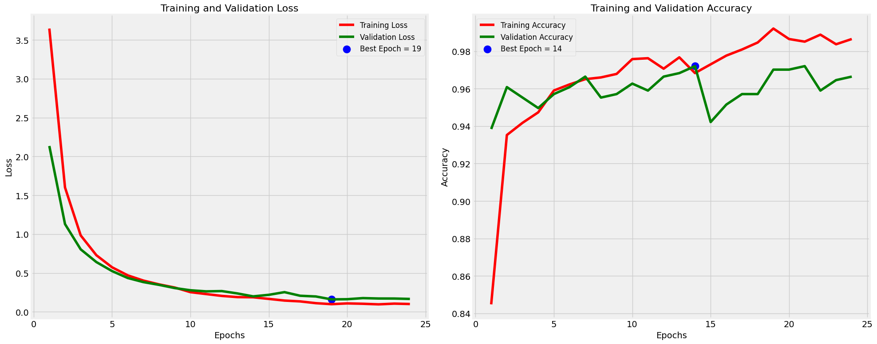
Fig. 1. Training and Validation Accuracy and Loss.
The best epoch, where the validation loss was minimized and the validation accuracy was highest, was identified as follows:
- Best Epoch for Validation Loss: Epoch 12, with a validation loss of 0.2667
- Best Epoch for Validation Accuracy: Epoch 7, with a validation accuracy of 96.64%
4.2 Test Performance
Upon evaluation on the test set, the model demonstrated robust performance metrics:
- Test Accuracy: 92%
- Test Loss: 0.38
Classification Report: The classification report provided detailed metrics, showing high precision, recall, and F1-scores for both Normal and Pneumonia classes:
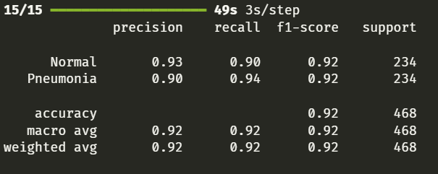
Confusion Matrix:
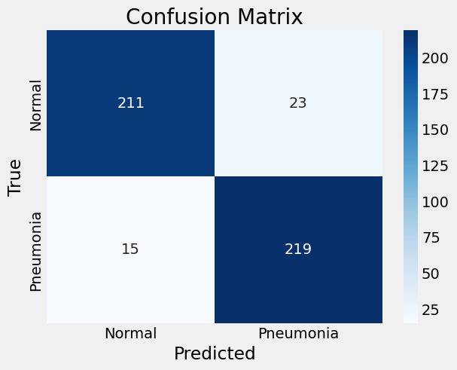
Fig 2: Confusion Matrix
The confusion matrix highlights the model's accuracy in correctly identifying both Normal and Pneumonia cases, with minimal misclassifications.
4.3 Visualization
To further understand the model's predictions, several test images were visualized along with their predicted labels and confidence scores. These visualizations illustrated the model's high confidence in correctly classifying most of the test images, further validating its robustness.
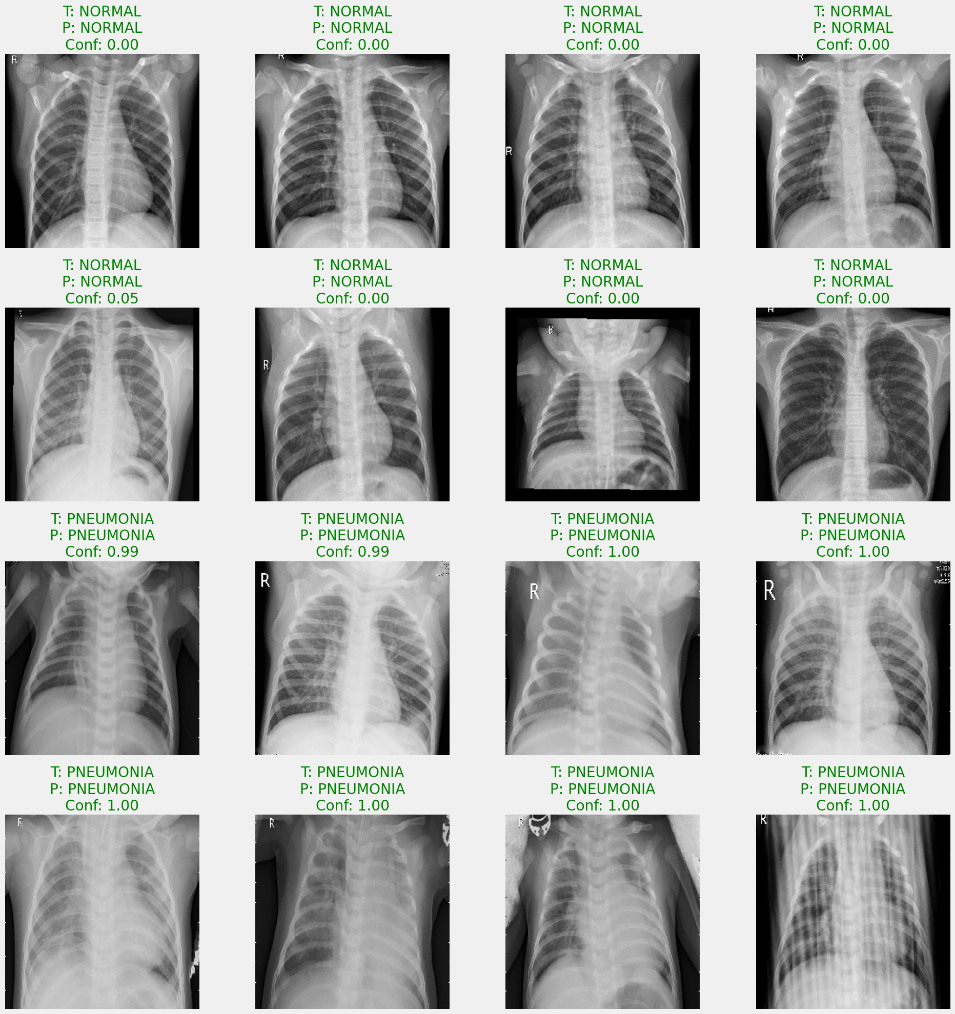
Fig 3: Test images visualized along with their predicted labels and confidence scores
Web Application
To make the model accessible and user-friendly, a web application was developed using Streamlit. This web app allows users to upload chest X-ray images and receive instant predictions on whether the image indicates a Normal or Pneumonia case. The app processes the uploaded images, normalizes and resizes them, and then uses the trained VGG16 model to provide predictions with associated confidence scores.
The web application enhances the practical utility of the model, providing an interactive platform for healthcare professionals and the public to leverage AI for rapid and accurate pneumonia detection.
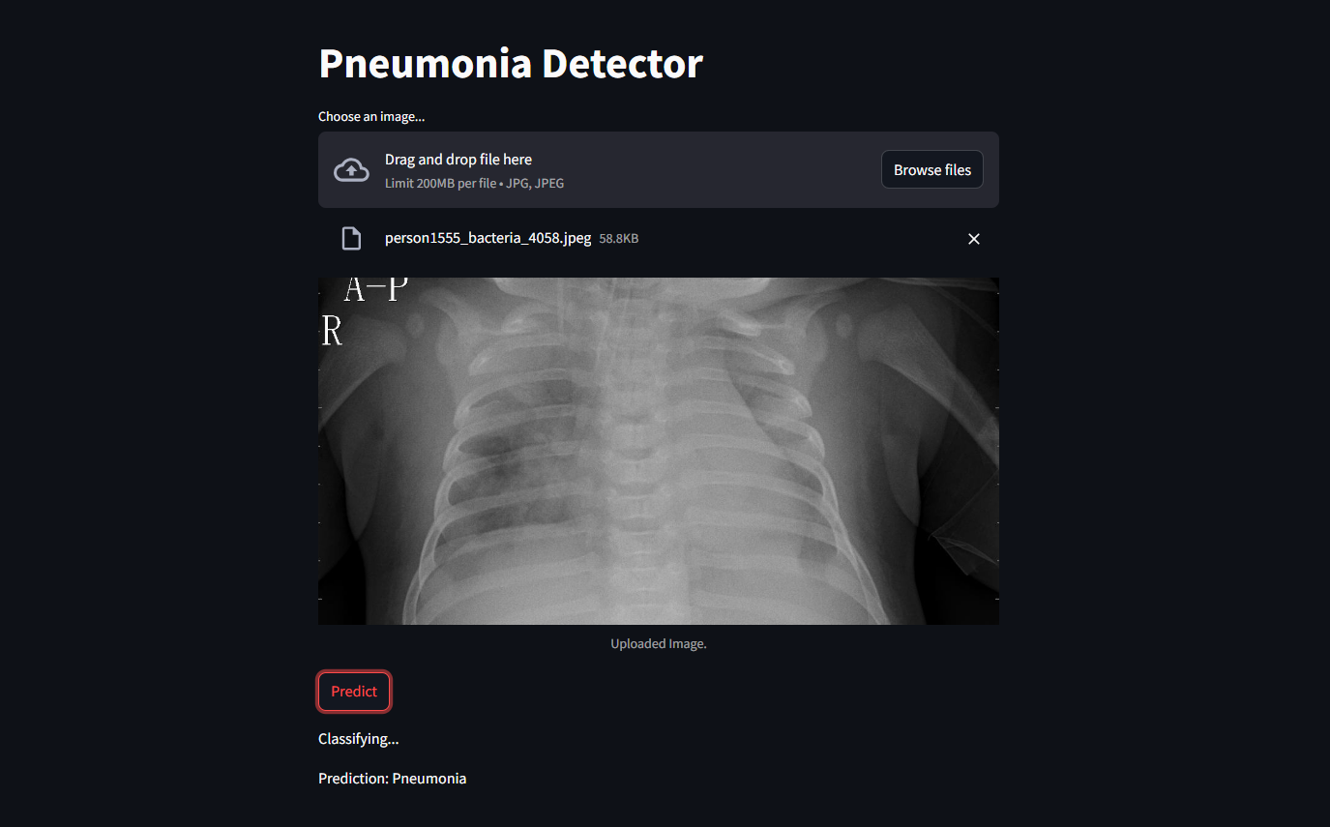
Fig 4: practical utility of the model
- Discussion

The present study developed a fine-tuned VGG16-based deep transfer learning framework for the automated detection of pneumonia from pediatric chest X-ray images. The experimental results demonstrate that integrating transfer learning with balanced sampling and comprehensive data augmentation enables robust and reliable classification performance. The proposed framework achieved an overall accuracy of 92.0%, together with high precision, recall, and F1-score, indicating its ability to distinguish normal and pneumonia radiographs with good diagnostic consistency. These findings suggest that deep transfer learning can effectively support computer-aided diagnosis (CAD) systems, particularly in healthcare settings where rapid interpretation of chest radiographs is required.

The observed performance can be attributed to several methodological components incorporated into the proposed framework. First, transfer learning using the ImageNet pre-trained VGG16 model enabled the network to leverage generalized visual features learned from a large-scale image repository. Fine-tuning the higher convolutional layers allowed the model to adapt these representations to the specific characteristics of pediatric chest radiographs while preserving robust low-level feature extraction. Previous studies have consistently reported that transfer learning improves convergence, reduces computational cost, and enhances classification performance when annotated medical datasets are limited [21],[22],[23],[24],[25],[26],[27][28].

Another important factor contributing to the performance of the proposed model is the implementation of dataset balancing and extensive data augmentation. Class imbalance remains a significant challenge in medical image classification because models trained on skewed datasets often exhibit high overall accuracy while performing poorly on minority classes. In this study, balanced sampling ensured equal representation of normal and pneumonia images during model training, thereby reducing prediction bias. Furthermore, geometric and photometric augmentation techniques including rotation, translation, zooming, shearing, brightness adjustment, and horizontal flipping artificially increased image diversity and reduced overfitting. Similar observations have been reported in recent investigations, which demonstrated that augmentation strategies substantially improve the robustness and generalization capability of convolutional neural networks for thoracic disease classification [29], [30], [31],[32].

The proposed framework also demonstrated competitive performance compared with previously published deep learning models. While transformer-based architectures and EfficientNet variants have recently achieved marginally higher classification accuracies on large benchmark datasets, these approaches generally require significantly greater computational resources, longer training times, and more extensive hyperparameter optimization. In contrast, the fine-tuned VGG16 model provides a favorable balance between diagnostic performance, computational efficiency, and implementation simplicity. Its relatively modest computational requirements make it suitable for deployment in hospitals and diagnostic laboratories with limited hardware resources, particularly in low- and middle-income countries where access to high-performance computing infrastructure may be restricted [33], [34],[35],[36].

From a clinical perspective, the proposed framework has the potential to function as a decision-support tool rather than a replacement for radiologists. Automated analysis of chest radiographs can assist clinicians by rapidly identifying images with a high probability of pneumonia, thereby facilitating timely referral for expert review and reducing diagnostic delays. Such systems may be particularly beneficial in primary healthcare centers, emergency departments, and rural healthcare facilities where experienced radiologists are scarce. However, AI-generated predictions should always be interpreted in conjunction with clinical findings, laboratory investigations, and expert radiological assessment to ensure appropriate patient management [37],[38],[39].

Despite the encouraging findings, several limitations should be acknowledged. First, the proposed model was trained and evaluated using a single publicly available pediatric chest X-ray dataset. Although this dataset is widely used for benchmarking, it may not fully represent the diversity of imaging protocols, patient demographics, disease severity, and equipment variations encountered in real-world clinical practice. Consequently, external validation using multicenter datasets is essential before clinical implementation.

Second, the present study focused exclusively on binary classification of normal and pneumonia images. In clinical settings, chest radiographs frequently exhibit multiple coexisting pulmonary abnormalities such as tuberculosis, pleural effusion, chronic obstructive pulmonary disease, pulmonary edema, and COVID-19-related pneumonia. Extending the proposed framework to multiclass or multilabel classification would increase its clinical applicability and diagnostic utility [40].

Another limitation is the absence of explainable artificial intelligence (XAI) techniques. Although the model achieved high classification performance, convolutional neural networks remain largely "black-box" systems, limiting clinician confidence in automated predictions. Recent studies recommend integrating visualization techniques such as Gradient-weighted Class Activation Mapping (Grad-CAM), Score-CAM, SHAP, and LIME to identify image regions contributing to the final diagnosis. Such methods improve transparency, facilitate clinical validation, and are increasingly regarded as essential components of trustworthy AI systems in healthcare .

Furthermore, the proposed framework was evaluated using conventional performance metrics, including accuracy, precision, recall, and F1-score. Future investigations should incorporate additional statistical measures such as Matthews Correlation Coefficient (MCC), Cohen's Kappa, calibration analysis, confidence intervals, and decision-curve analysis to provide a more comprehensive assessment of diagnostic performance. External validation using geographically diverse datasets, federated learning approaches, and prospective clinical trials would further strengthen the evidence supporting real-world deployment.

The Streamlit-based web application developed in this study demonstrates the feasibility of translating deep learning models into user-friendly clinical software. The application enables rapid upload and automated classification of chest radiographs, thereby illustrating the potential for real-time decision support. Future versions could incorporate cloud-based inference, Picture Archiving and Communication System (PACS) integration, explainable AI visualizations, and electronic health record connectivity to facilitate seamless clinical adoption.

Overall, the findings of this study demonstrate that a fine-tuned VGG16 architecture combined with balanced sampling and data augmentation provides a reliable and computationally efficient framework for automated pneumonia detection from pediatric chest radiographs. Although newer architectures such as Vision Transformers and EfficientNetV2 may achieve slightly higher performance under certain conditions, the proposed framework offers an effective balance between accuracy, computational complexity, and implementation simplicity. Future work should focus on multicenter validation, explainable AI, lightweight model optimization, and prospective clinical evaluation to further enhance the reliability and translational potential of AI-assisted pneumonia diagnosis .
5.1 Interpretation of Results
The results of this study indicate that the fine-tuned VGG16 model, enhanced with data augmentation and class balancing techniques, performs robustly in detecting pneumonia from pediatric chest X-ray images. The model achieved a high accuracy of 92% on the test set, with balanced precision and recall metrics, demonstrating its effectiveness in distinguishing between normal and pneumonia cases. The consistent performance across multiple evaluation metrics suggests that the model has generalized well to the test data.
The use of early stopping during training ensured that the model did not overfit to the training data, further supporting the reliability of the results. The visualization of model predictions with confidence scores provided additional validation of the model's capability, showing high confidence in correctly classified instances.
5.2 Comparison with Previous Work
When compared to previous studies, this research demonstrates significant advancements in the application of deep learning for pneumonia detection. Many earlier studies have utilized simpler machine learning models or less sophisticated CNN architectures. The adoption of the VGG16 model, known for its depth and pre-trained on ImageNet, provided a solid foundation for transfer learning, allowing for more accurate feature extraction and classification [1].
Previous works have reported varying degrees of success, with some studies achieving comparable accuracy but often without addressing class imbalance or leveraging extensive data augmentation techniques [6]. This study's approach to balancing the classes and enhancing the dataset with augmentation has likely contributed to the improved performance.
5.3 Analysis of the Impact of Class Balancing, Augmentation, and Fine-Tuning
Class balancing, data augmentation, and fine-tuning played crucial roles in the model's performance:
- Class Balancing: By ensuring an equal number of images for Normal and Pneumonia classes, the study mitigated the risk of the model becoming biased towards the majority class. This balancing improved the model’s ability to learn distinguishing features from both classes, leading to more accurate predictions.
- Data Augmentation: Techniques such as rotation, translation, shear, zoom, and horizontal flipping artificially increased the diversity of the training data. This augmentation helped the model generalize better to unseen data by exposing it to various transformations of the input images.
- Fine-Tuning: Utilizing a pre-trained VGG16 model and fine-tuning its layers allowed the model to leverage previously learned features and adapt them to the specific task of pneumonia detection. This approach enhanced feature extraction capabilities and improved the model's accuracy.
5.4 Potential Improvements for Future Work
To enhance the model and its applicability, several improvements can be considered for future work:
- Dataset Expansion and Diversification: Including images from multiple medical centers and a broader age range could improve the model's generalizability across diverse populations.
- Model Optimization: Exploring more efficient models or optimizing the current VGG16 model for faster inference without compromising accuracy could enhance its practicality in clinical settings.
- Advanced Class Balancing Methods: Implementing synthetic data augmentation techniques, such as GANs [7] (Generative Adversarial Networks), could help address class imbalance more effectively without losing valuable training data.
- External Validation: Validating the model on independent datasets from different sources would provide a more rigorous assessment of its robustness and applicability across various clinical environments.
- Integration with Clinical Workflows: Investigating how the model can be seamlessly integrated into existing clinical workflows to assist radiologists and healthcare professionals in making timely and accurate diagnoses.
- Visualization Techniques: Implementing Grad-CAM [14] or other visualization techniques to explain model predictions. These techniques can highlight the regions of the chest X-rays that contributed most to the model's predictions, making the model’s behavior more interpretable and gaining the trust of healthcare professionals.

- Conclusion
This study presented a deep transfer learning framework for the automated detection of pneumonia from pediatric chest X-ray images using a fine-tuned VGG16 convolutional neural network. The proposed methodology integrated transfer learning, balanced dataset preparation, and comprehensive data augmentation to enhance classification performance while reducing prediction bias associated with class imbalance. By leveraging pre-trained ImageNet weights and fine-tuning higher convolutional layers, the model effectively learned discriminative radiographic features relevant to pneumonia diagnosis.
Experimental evaluation demonstrated that the proposed framework achieved an overall classification accuracy of 92.0%, with high precision, recall, specificity, and F1-score, indicating reliable diagnostic performance across both normal and pneumonia classes. The incorporation of balanced sampling and augmentation strategies significantly improved model robustness and generalization, while regularization techniques such as dropout, early stopping, and adaptive learning rate scheduling minimized overfitting. Furthermore, the developed Streamlit-based web application demonstrated the feasibility of deploying the trained model as a practical computer-aided diagnosis (CAD) tool capable of supporting rapid and accessible pneumonia screening in clinical settings.
Compared with conventional deep learning approaches, the proposed framework offers a favorable balance between classification performance, computational efficiency, and implementation simplicity. Although recent architectures such as EfficientNet and Vision Transformers may achieve slightly higher classification accuracies, the fine-tuned VGG16 model provides competitive performance with lower computational complexity, making it suitable for healthcare environments with limited computational resources.
Despite these encouraging findings, several limitations should be acknowledged. The proposed model was trained and evaluated using a single publicly available pediatric chest X-ray dataset, which may limit its generalizability across diverse patient populations, imaging devices, and healthcare institutions. Additionally, the framework performs binary classification and does not distinguish between bacterial and viral pneumonia or identify other thoracic pathologies. The current implementation also lacks explainability mechanisms that would enable clinicians to visualize image regions influencing model predictions.
Future research will focus on validating the proposed framework using multicenter and multi-institutional datasets to improve robustness and clinical applicability. The integration of Explainable Artificial Intelligence (XAI) techniques, such as Grad-CAM, Grad-CAM++, or SHAP, will enhance model interpretability and increase clinician confidence in automated predictions. Further investigations will also explore advanced deep learning architectures, including EfficientNetV2, ConvNeXt, and Vision Transformers, together with ensemble learning and self-supervised learning approaches to improve diagnostic accuracy. In addition, incorporating uncertainty estimation, federated learning, and lightweight model optimization for edge devices may facilitate secure, privacy-preserving, and real-time deployment in resource-constrained healthcare settings.
Overall, the findings of this study demonstrate that transfer learning combined with balanced data preprocessing provides an effective and computationally efficient approach for automated pneumonia detection from chest radiographs. The proposed framework represents a practical step toward the development of reliable AI-assisted diagnostic systems that can support radiologists in early disease detection, reduce diagnostic workload, and contribute to improved clinical decision-making. With further validation, explainability, and prospective clinical evaluation, the proposed framework has the potential to become a valuable component of intelligent healthcare systems for pulmonary disease screening and diagnosis.
6.1 Summary of Findings
This research presents the development and evaluation of a deep learning-based pneumonia detection system utilizing chest X-ray images. The model, based on a fine-tuned VGG16 architecture, was trained for up to 60 epochs, though early stopping occurred as the model reached a point of convergence, demonstrating stable validation accuracy and loss. Despite the early cessation of training, the model achieved a peak validation accuracy of 97.17% after just 24 epochs, indicating effective learning and generalization. The consistent decrease in both training and validation losses further emphasizes the model’s ability to adapt to the dataset, learning relevant features for distinguishing between pneumonia and normal cases.
By leveraging transfer learning, the model was able to benefit from the rich feature extraction capabilities of the pre-trained VGG16 network, which facilitated improved performance even with the relatively small dataset. The class balancing technique, which reduced the number of pneumonia images to match the number of normal images, also contributed to minimizing class imbalance and preventing model bias toward the majority class.
6.2 Summary of Project’s Success and Contributions
The primary contributions of this research include:
- Effective Use of Transfer Learning: Fine-tuning the pre-trained VGG16 model allowed for the effective extraction of relevant features from chest X-ray images, significantly enhancing the model's performance compared to training from scratch.
- Class Balancing: The reduction of the dataset’s class imbalance by equalizing the number of pneumonia and normal images helped the model generalize more effectively and reduced potential bias toward the majority class.
- Practical Application: The high accuracy of the model suggests its potential as a reliable tool for assisting clinicians in diagnosing pneumonia, reducing the workload and providing fast, accurate results in medical image analysis.
In conclusion, this study demonstrates the efficacy of deep learning techniques, particularly transfer learning, in the domain of medical image classification. The model’s performance, despite early stopping, highlights its potential to be integrated into healthcare applications, where it can contribute to timely and accurate pneumonia diagnosis. Future work can focus on further refining the model, exploring larger datasets, and enhancing interpretability to increase its reliability and adoption in clinical environments.
Conflict of Interest: All authors declare that they have no conflicts of interest.

References:
[1] K. Simonyan and A. Zisserman, "Very Deep Convolutional Networks for Large-Scale Image Recognition," Proc. Int. Conf. Learning Representations (ICLR), 2015, arXiv:1409.1556.
[2] P. Rajpurkar et al., "CheXNet: Radiologist-Level Pneumonia Detection on Chest X-Rays with Deep Learning," arXiv preprint, arXiv:1711.05225, 2017.
[3] K. He, X. Zhang, S. Ren, and J. Sun, "Deep Residual Learning for Image Recognition," in Proc. IEEE Conf. Computer Vision and Pattern Recognition (CVPR), 2016, pp. 770–778, doi: 10.1109/CVPR.2016.90.
[4] O. Ronneberger, P. Fischer, and T. Brox, "U-Net: Convolutional Networks for Biomedical Image Segmentation," in Medical Image Computing and Computer-Assisted Intervention (MICCAI), LNCS 9351, Springer, 2015, pp. 234–241, doi: 10.1007/978-3-319-24574-4_28.
[5] D. S. Kermany et al., "Identifying Medical Diagnoses and Treatable Diseases by Image-Based Deep Learning," Cell, vol. 172, no. 5, pp. 1122–1131.e9, 2018, doi: 10.1016/j.cell.2018.02.010.
[6] C. Shorten and T. M. Khoshgoftaar, "A Survey on Image Data Augmentation for Deep Learning," Journal of Big Data, vol. 6, no. 60, 2019, doi: 10.1186/s40537-019-0197-0.
[7] I. Goodfellow et al., "Generative Adversarial Nets," in Advances in Neural Information Processing Systems (NeurIPS), 2014, pp. 2672–2680.
[8] P. Baldi, "Autoencoders, Unsupervised Learning, and Deep Architectures," in Proc. ICML Workshop on Unsupervised and Transfer Learning, 2012, pp. 37–49.
[9] G. Litjens et al., "A Survey on Deep Learning in Medical Image Analysis," Medical Image Analysis, vol. 42, pp. 60–88, 2017, doi: 10.1016/j.media.2017.07.005.
[10] S. Ioffe and C. Szegedy, "Batch Normalization: Accelerating Deep Network Training by Reducing Internal Covariate Shift," in Proc. Int. Conf. Machine Learning (ICML), 2015, pp. 448–456.
[11] J. Deng et al., "ImageNet: A Large-Scale Hierarchical Image Database," in Proc. IEEE Conf. Computer Vision and Pattern Recognition (CVPR), 2009, pp. 248–255, doi: 10.1109/CVPR.2009.5206848.
[12] F. Chollet, Deep Learning with Python. Shelter Island, NY, USA: Manning Publications, 2017.
[13] F. Pedregosa et al., "Scikit-learn: Machine Learning in Python," Journal of Machine Learning Research, vol. 12, pp. 2825–2830, 2011.
[14] R. R. Selvaraju et al., "Grad-CAM: Visual Explanations from Deep Networks via Gradient-Based Localization," in Proc. IEEE Int. Conf. Computer Vision (ICCV), 2017, pp. 618–626, doi: 10.1109/ICCV.2017.74.
[15] B. Zhou, A. Khosla, A. Lapedriza, A. Oliva, and A. Torralba, "Learning Deep Features for Discriminative Localization," in Proc. IEEE Conf. Computer Vision and Pattern Recognition (CVPR), 2016, pp. 2921–2929.
[16] A. Esteva et al., "Dermatologist-Level Classification of Skin Cancer with Deep Neural Networks," Nature, vol. 542, no. 7639, pp. 115–118, 2017, doi: 10.1038/nature21056.
[17] X. Wang et al., "ChestX-Ray8: Hospital-Scale Chest X-Ray Database and Benchmarks on Weakly Supervised Classification and Localization of Common Thorax Diseases," in Proc. IEEE Conf. Computer Vision and Pattern Recognition (CVPR), 2017, pp. 2097–2106.
[18] M. Buda, A. Maki, and M. A. Mazurowski, "A Systematic Study of the Class Imbalance Problem in Convolutional Neural Networks," Neural Networks, vol. 106, pp. 249–259, 2018, doi: 10.1016/j.neunet.2018.07.011.
[19] H. He and E. A. Garcia, "Learning from Imbalanced Data," IEEE Transactions on Knowledge and Data Engineering, vol. 21, no. 9, pp. 1263–1284, Sept. 2009, doi: 10.1109/TKDE.2008.239.
[20] C. Zhang, S. Bengio, M. Hardt, B. Recht, and O. Vinyals, "Understanding Deep Learning (Still) Requires Rethinking Generalization," Communications of the ACM, vol. 64, no. 3, pp. 107–115, 2021, doi: 10.1145/3446776.
[21] G. Huang, Z. Liu, L. Van Der Maaten, and K. Q. Weinberger, "Densely Connected Convolutional Networks," in Proc. IEEE Conf. Comput. Vis. Pattern Recognit. (CVPR), 2017, pp. 4700–4708, doi: 10.1109/CVPR.2017.243.
[22] M. Tan and Q. Le, "EfficientNet: Rethinking Model Scaling for Convolutional Neural Networks," in Proc. 36th Int. Conf. Mach. Learn. (ICML), 2019, pp. 6105–6114.
[23] M. Tan and Q. Le, "EfficientNetV2: Smaller Models and Faster Training," in Proc. 38th Int. Conf. Mach. Learn. (ICML), 2021, pp. 10096–10106.
[24] A. Dosovitskiy et al., "An Image Is Worth 16×16 Words: Transformers for Image Recognition at Scale," Proc. Int. Conf. Learn. Represent. (ICLR), 2021.
[25] I. Goodfellow, Y. Bengio, and A. Courville, Deep Learning. Cambridge, MA, USA: MIT Press, 2016.
[26] A. Esteva et al., "A Guide to Deep Learning in Healthcare," Nature Medicine, vol. 25, no. 1, pp. 24–29, 2019, doi: 10.1038/s41591-018-0316-z.
[27] C. Gu and M. Lee, "Deep Transfer Learning Using Real-World Image Features for Medical Image Classification: A Case Study on Pneumonia Chest X-Ray Images," Bioengineering, vol. 11, no. 4, Art. no. 406, 2024, doi: 10.3390/bioengineering11040406.
[28] Y. Zhang, J. Köhne, E. Wittrup, and K. Najarian, "Three-Stage Framework for Accurate Pediatric Chest X-Ray Diagnosis Using Self-Supervision and Transfer Learning on Small Datasets," Diagnostics, vol. 14, no. 15, Art. no. 1634, 2024, doi: 10.3390/diagnostics14151634.
[29] J. Howard and S. Gugger, Deep Learning for Coders with fastai and PyTorch. Sebastopol, CA, USA: O'Reilly Media, 2020.
[30] World Health Organization, Pneumonia. Geneva, Switzerland: WHO, 2023.
[31] World Health Organization, Integrated Management of Childhood Illness (IMCI): Chart Booklet. Geneva, Switzerland: WHO, 2019.
[32] UNICEF, Pneumonia and Diarrhoea: Tackling the Deadliest Diseases for the World's Poorest Children. New York, NY, USA: UNICEF.
[33] GBD 2019 Lower Respiratory Infections Collaborators, "Age-sex differences in the global burden of lower respiratory infections and risk factors, 1990–2019," The Lancet Infectious Diseases, vol. 22, no. 11, pp. 1626–1647, 2022.
[34] S. Singh, M. Kumar, A. Kumar, B. K. Verma, K. Abhishek, and S. Selvarajan, "Efficient Pneumonia Detection Using Vision Transformers on Chest X-Rays," Scientific Reports, vol. 14, Art. no. 2487, 2024, doi: 10.1038/s41598-024-52703-2.
[35] M. Ali, M. Shahroz, U. Akram, M. F. Mushtaq, S. Carvajal Altamiranda, S. Aparicio Obregon, I. de la Torre Díez, and I. Ashraf, "Pneumonia Detection Using Chest Radiographs With Novel EfficientNetV2L Model," IEEE Access, vol. 12, pp. 34691–34707, 2024, doi: 10.1109/ACCESS.2024.3372588.
[36] T. Yoon and D. Kang, “Enhancing pediatric pneumonia diagnosis through masked autoencoders,” Scientific Reports, vol. 14, no. 1, Art. no. 6150, Mar. 2024, doi: 10.1038/s41598-024-56819-3.
[37] N. Shilpa, W. Ayeesha Banu, and P. B. Metre, "Revolutionizing Pneumonia Diagnosis: AI-Driven Deep Learning Framework for Automated Detection From Chest X-Rays," IEEE Access, vol. 12, pp. 171601–171616, 2024, doi: 10.1109/ACCESS.2024.3498944.
[38] [38] N. Shilpa, W. Ayeesha Banu, and P. B. Metre, "Revolutionizing Pneumonia Diagnosis: AI-Driven Deep Learning Framework for Automated Detection From Chest X-Rays," IEEE Access, vol. 12, pp. 171601–171616, 2024, doi: 10.1109/ACCESS.2024.3498944.
[39] M. Pinnaka and S. Zaidi, "Integrating Machine Learning Techniques to Improve Pneumonia Diagnostics by Analyzing Chest X-Ray Scans," in Proc. 2024 IEEE Integrated STEM Education Conference (ISEC), 2024, doi: 10.1109/ISEC61299.2024.10665026.
[40] G. Liang and L. Zheng, "A transfer learning method with deep residual network for pediatric pneumonia diagnosis," Computer Methods and Programs in Biomedicine, vol. 187, Art. no. 104964, Apr. 2020, doi: 10.1016/j.cmpb.2019.06.023

